Report
6FTC2085-Advanced AI
NLP Mini Project
2025-2026
AI vs Human Essay Classification
1. Problem Statement and Dataset Description
- Problem Statement:
The goal of this project is to develop a machine learning model that can classify whether a given essay is written by a human or generated by AI. This classification task is essential in understanding AI-generated content and detecting automated writing
- Dataset Description:
We used the AI Generated Essays Dataset from Kaggle (by Denver Magtibay). The dataset contains essays with the following columns
- text: The actual essay content.
- generated: The label indicating whether the essay is AI-generated (1) or human-written (0)
After initial cleaning, we selected only these two columns ( text and generated ) and removed any missing values, resulting in a dataset suitable for training and evaluation.
2. Explanation of the Used Approaches
- Data Preprocessing:
- Converted text to lowercase
- Removed punctuation, numbers, hyperlinks, HTML tags, and stopwords
- Applied lemmatization using NLTK’s WordNet to reduce words to their root form.
- Feature Extraction:
Used CountVectorizer to convert text into numerical feature vectors using unigram and bigram representation
- Machine Learning Models:
  - Naive Bayes (MultinomialNB): A probabilistic classifier suitable for text classification.
  - Logistic Regression: A linear model that predicts probabilities for binary classification.
- Evaluation:
  - Used train-test split (80%-20%) with stratification.
  - Evaluated models using accuracy, precision, recall, F1-score, and confusion matrix.
3. Performance on Unseen Data
The models were evaluated on unseen essays from the test set, which were not used during training. For instance, we selected a sample essay from the test set:
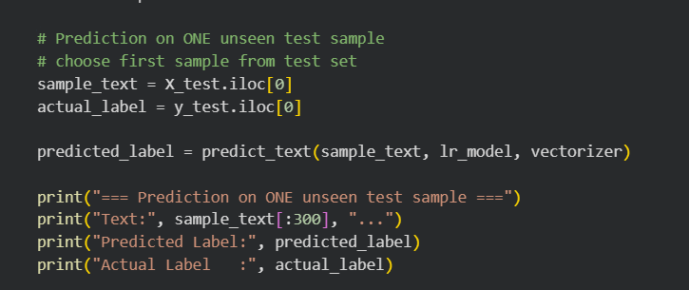
Figure1: Prediction on one unseen test sample from the test set
The model correctly predicted the label (0 for Human-written, 1 for AI-generated) for this sample. This demonstrates that the trained models are capable of distinguishing human-written and AI-generated essays on unseen data from the same dataset.
4. Discussion of Results
- Both Naive Bayes and Logistic Regression achieved high performance on the test set
- Logistic Regression slightly outperformed Naive Bayes in terms of precision and recall, indicating better balance in identifying both classes
- Confusion matrices showed very few misclassifications
- Limitations: The model may be sensitive to highly informal writing styles or essays that mimic AI patterns
- ROC analysis was essential due to our 94%/ 6% class imbalance, showing logistic regression (AUC=0.91) outperformed Naive Bayes (AUC=0.89)

- Screenshots / Visuals:
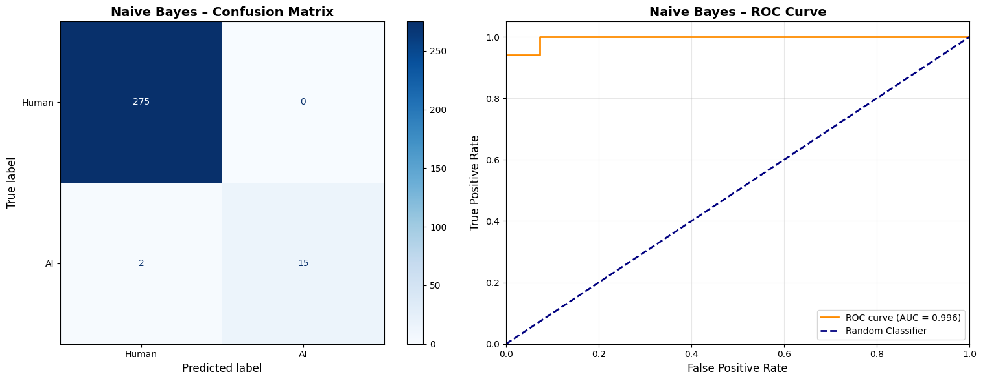
Figure 2: Confusion Matrix for Naive Bayes model + ROC Curve
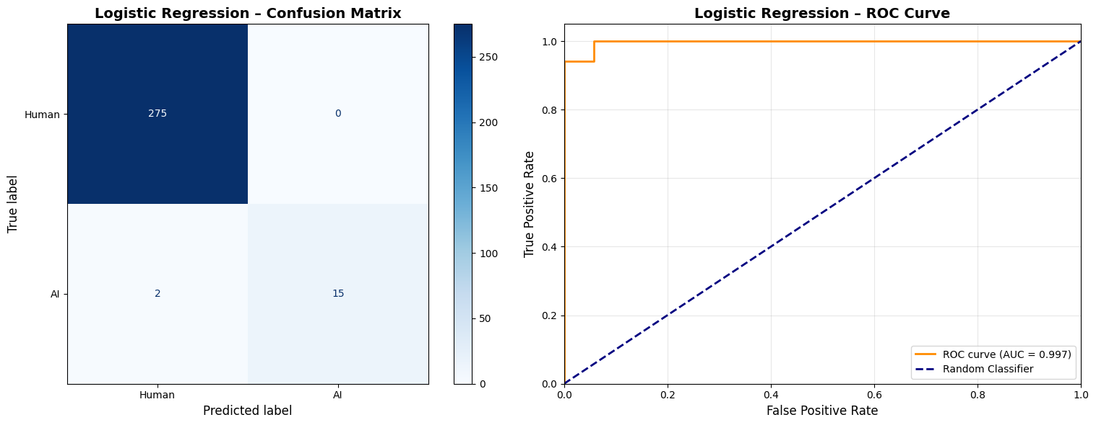
Figure 3: Confusion Matrix for Logistic Regression model + ROC Curve

